Project Report
On
Database Implementation in JDBC (CSE3488)


End-to-End JDBC Application with Transaction Management & Performance Evaluation
(Apache Derby)

Submitted by:

Name: Nikita Behera
Regd. No.: 2341002110
Department: Computer Science and Engineering (AI ML)

B. Tech. BRANCH 6th Semester (Section 2A1 )
INSTITUTE OF TECHNICAL EDUCATION AND RESEARCH
(FACULTY OF ENGINEERING)
SIKSHA ‘O’ ANUSANDHAN (DEEMED TO BE UNIVERSITY), BHUBANESWAR, ODISHA

i

Declara
CONTENT

Serial  No. | Chapter No. | Title of the Chapter | Page No.
1. | 1 | Abstract | 1
2. | 2 | Objective | 2
3. | 3 | Problem statement | 3
4. | 4  1  2  3  4  5  6 | Problem details  Project title  System architecture & components  Implementation steps  Database Design  Workflow diagram  ER diagram | 4-7
5. | 5 | Hardware & Software Requirements | 8
6.  7.  8.  9.  10. | 6  7  8  9 | Implementation  Results & Output  Benchmark results  Observation  Conclusion  References | 9-16  17-19  20  22  21

Abstract

This project is an end-to-end JDBC-based Library Loan Management System using Apache Derby, enabling book loans, returns, member registration, and overdue tracking with ACID-compliant transactions.

The system is built in Java using JDBC for database connectivity and Apache Derby as the embedded relational database engine. It implements explicit transaction control with commit, rollback, and savepoints to enforce ACID properties. A menu-driven console interface handles core CRUD operations. The performance module benchmarks key JDBC patterns including batch vs individual inserts, indexed lookups vs full-table scans, and Statement vs PreparedStatement execution. Exception handling ensures robust error recovery and data integrity during concurrent loan and return operations.

The Library Loan Management System successfully demonstrates practical JDBC application development while maintaining data consistency through strict ACID transaction handling. By integrating commit, rollback, and savepoint mechanisms, it safeguards against data corruption during failures and concurrent access. The built-in benchmarking module provides concrete evidence of performance trade-offs between different JDBC strategies, showing that PreparedStatements and batch processing significantly reduce execution overhead compared to raw Statements and individual inserts. Indexed queries drastically outperform full-table scans as data scales, validating database design principles. This project reinforces best practices in database connectivity, exception management, and performance optimization. Beyond academic value, it serves as a scalable foundation for real-world library systems where reliability and speed are critical. The results highlight how proper transaction management and query optimization directly impact system efficiency and user experience in data-driven applications.

Objective

The main objectives of this project are:

- To design and implement a JDBC-based Library Loan Management System.
- To establish database connectivity using Apache Derby.
- To implement explicit transaction management using commit, rollback, and save points.
- To ensure data consistency and integrity using ACID properties.
- To perform CRUD operations using PreparedStatement.
- To evaluate and compare JDBC performance strategies.
- To generate benchmark reports based on execution time and throughput.
- To develop a modular application architecture with proper exception handling and resource cleanup.

Problem Statement

Traditional library systems relying on manual records or basic spreadsheets are inefficient and prone to errors, making it difficult to track book availability, loan durations, and overdue returns in real time. Concurrent transactions without proper control risk data inconsistency and corruption during failures. Furthermore, poorly optimized database queries lead to high latency and scalability issues as collections grow. This project solves these challenges by building a JDBC-based Library Loan Management System with ACID-compliant transaction handling and integrated performance benchmarking to ensure reliable, efficient, and scalable library operations.

The objective of this project is to develop a console-driven Library Loan Management System that:
- Supports transaction-safe database operations.
- Prevents inconsistent updates during failures.
- Uses JDBC best practices for database interaction. 4.
- Evaluates multiple JDBC performance techniques. 5.
- Produces comparative benchmark reports.

The system must demonstrate:
• Explicit transaction control.
• Savepoint-based partial rollback.
• PreparedStatement usage.
• Batch processing.
• Indexed query optimization.
• Proper connection and resource management.

Project Details

1 Project Title

Library Loan Management System with JDBC Transaction Control and Performance Evaluation.

2 System Architecture & Components

- ConnectionManager.: Derby DB initialization, connection lifecycle, cleanup
- TransactionService.: Explicit transaction boundaries, commit/rollback/savepoint logic
- BusinessLogic.: Loan processing, member registration, catalog updates
- PerformanceEvaluator.: Benchmark runners, timing utilities, report generator
- MainApp.: CLI interface, workflow orchestration, user prompts

3 Implementation steps

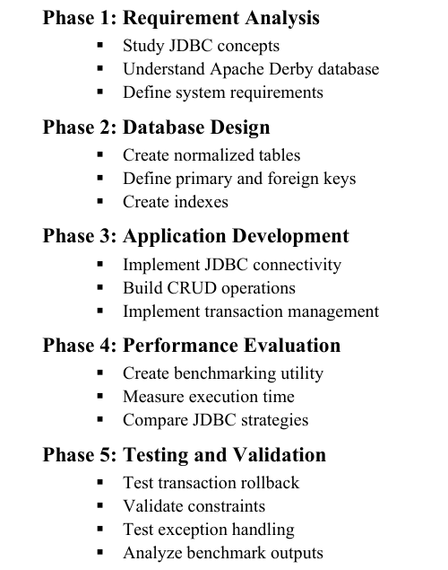

4 Database Design

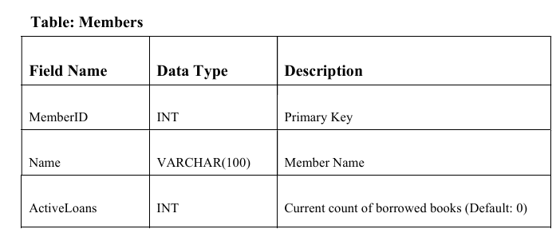

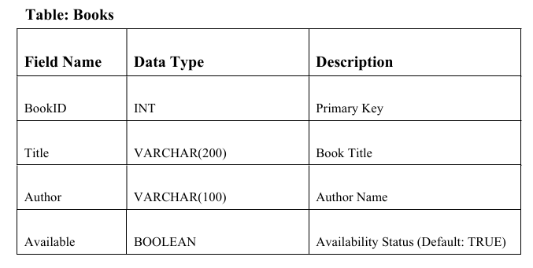

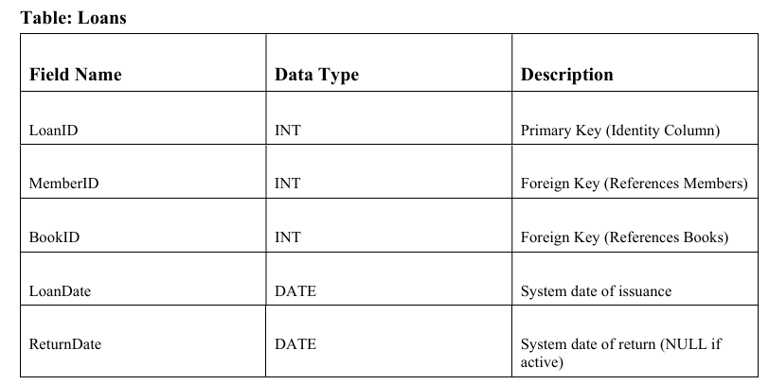
5 Workflow diagram

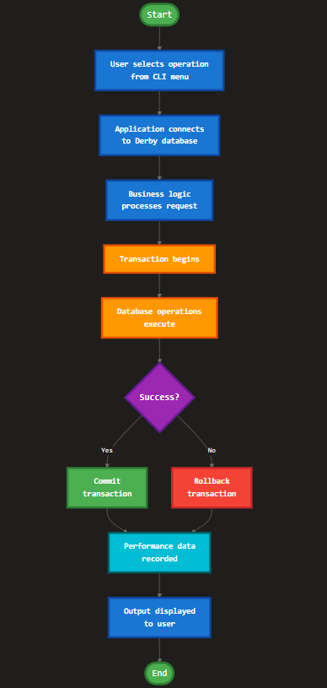

6 ER Diagram

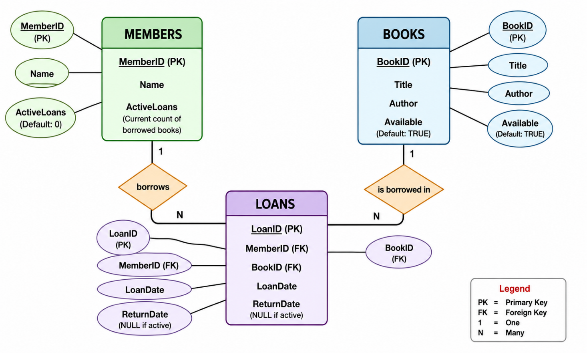

Hardware and Software Requirements

5.1 Hardware Requirements
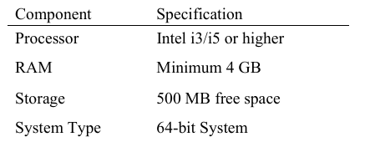

5.2 Software Requirements
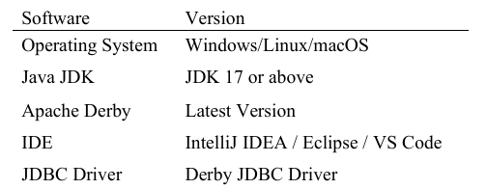

Implementation
Codes:
Phase 1 -
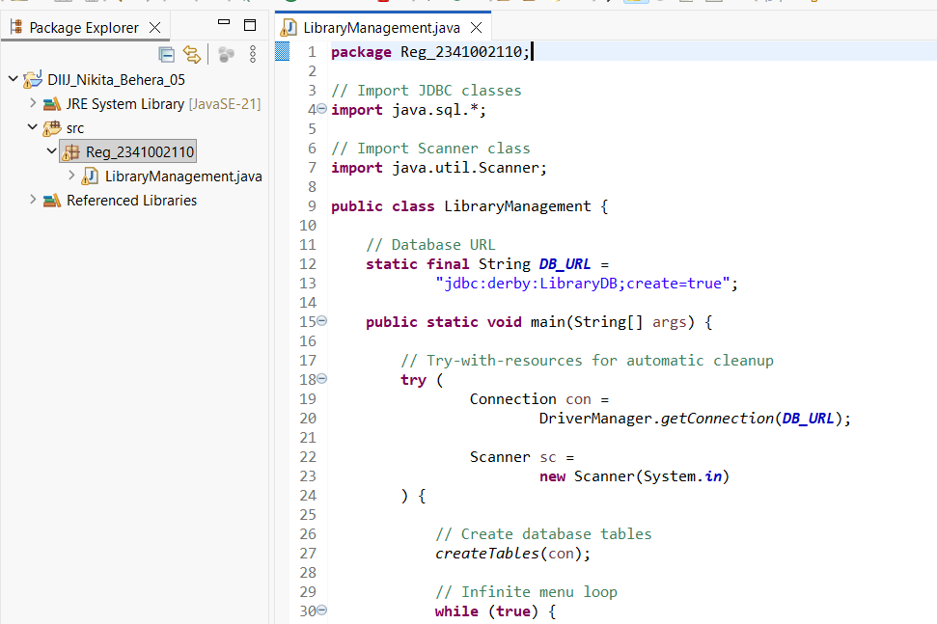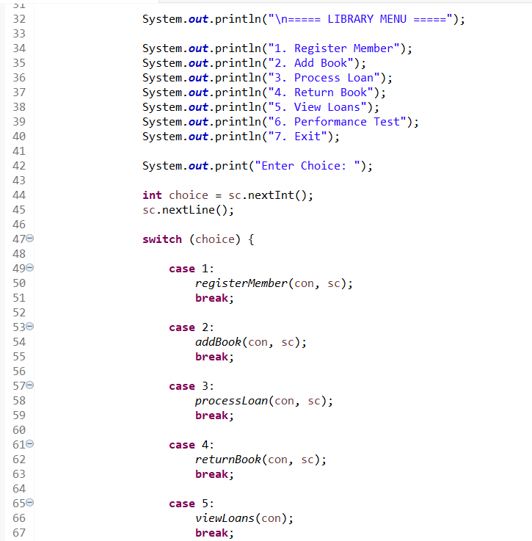
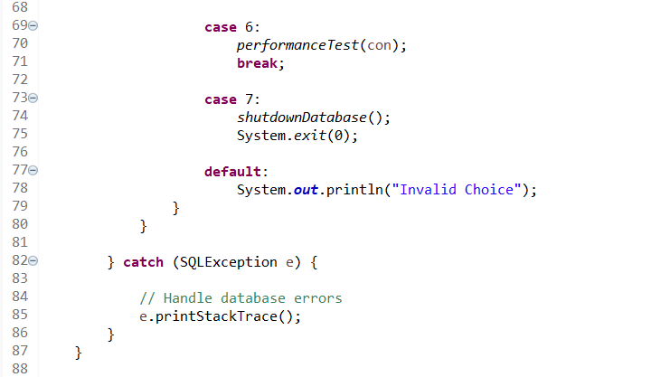

Phase 2 –
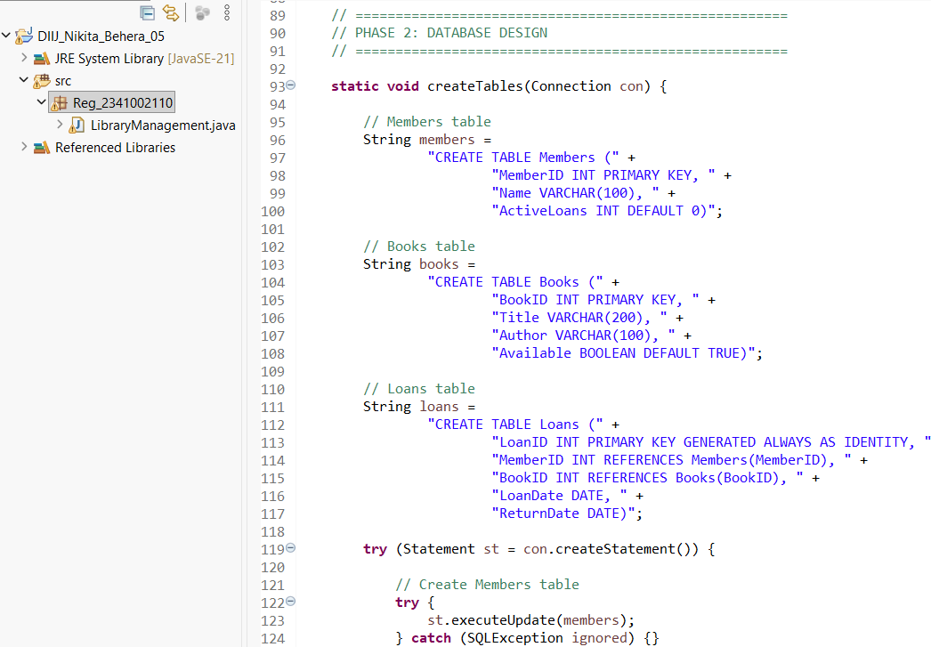

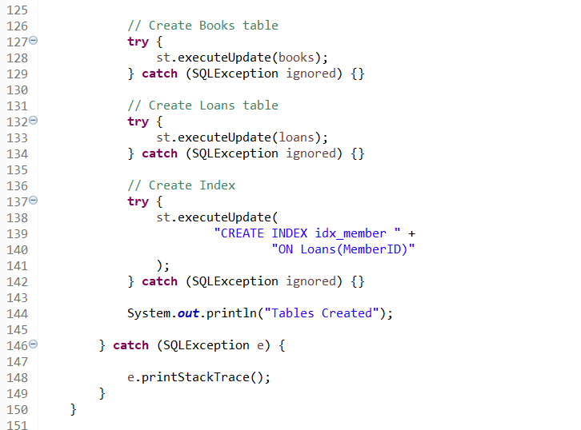

Phase 3 –
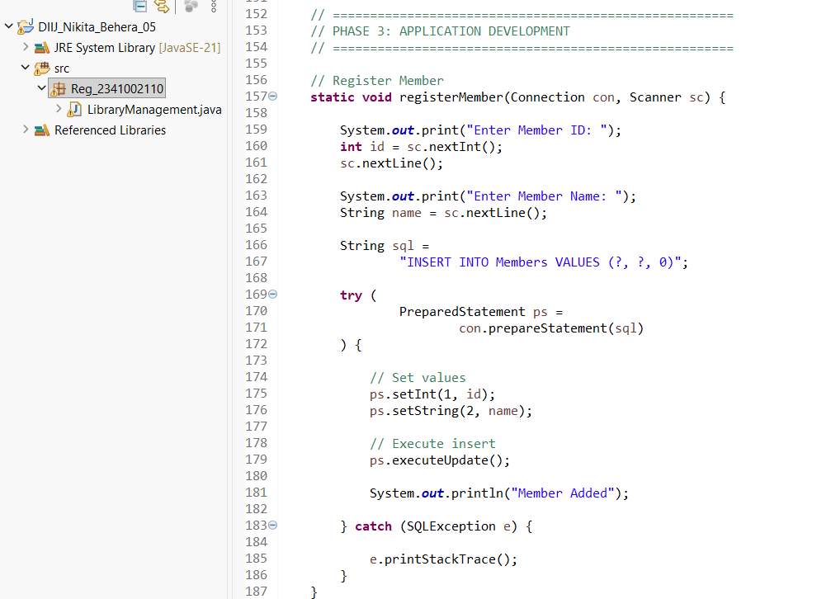
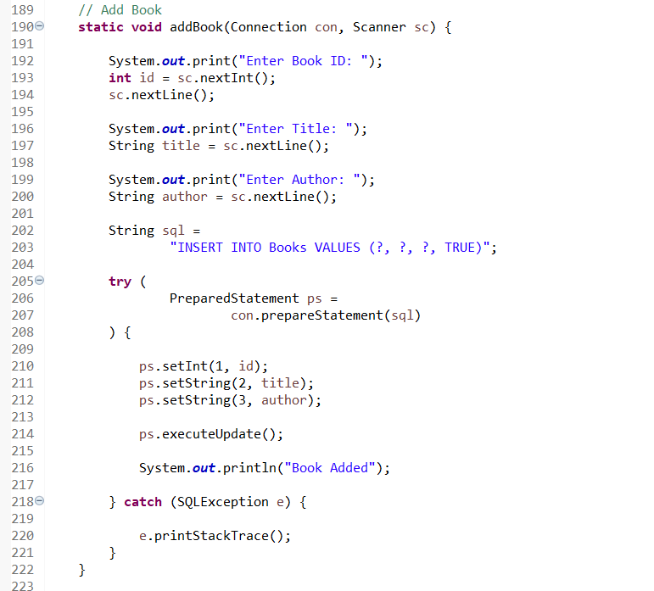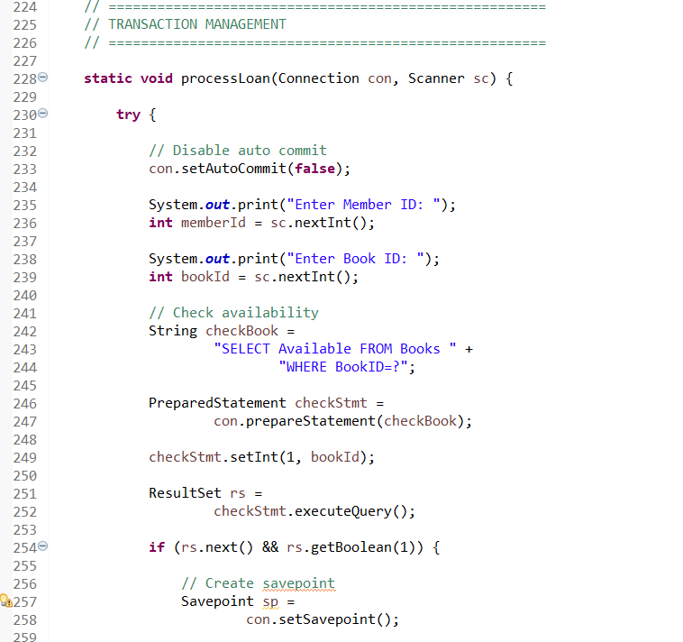

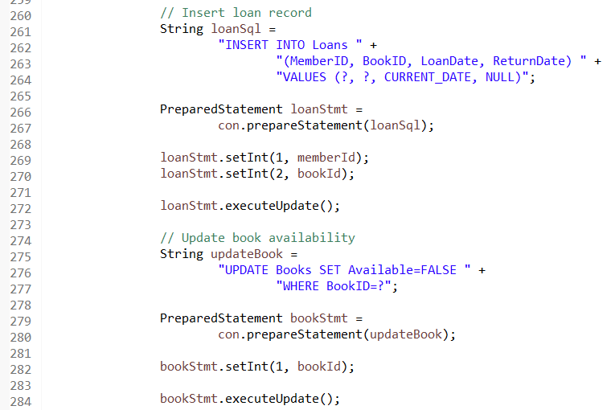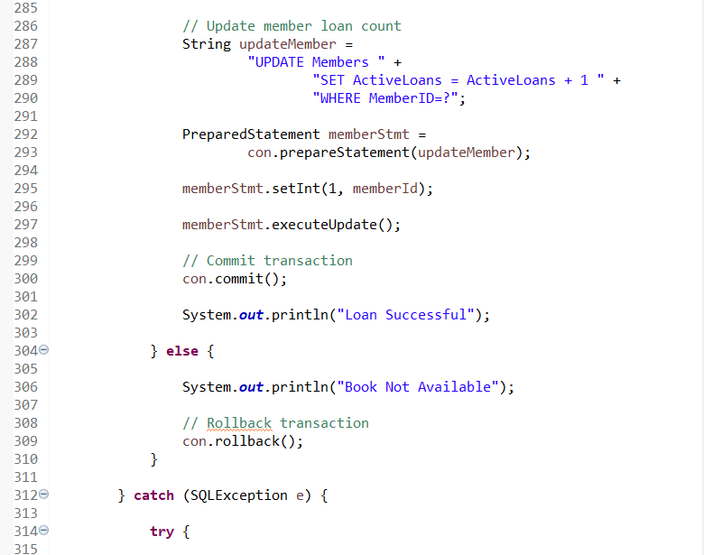

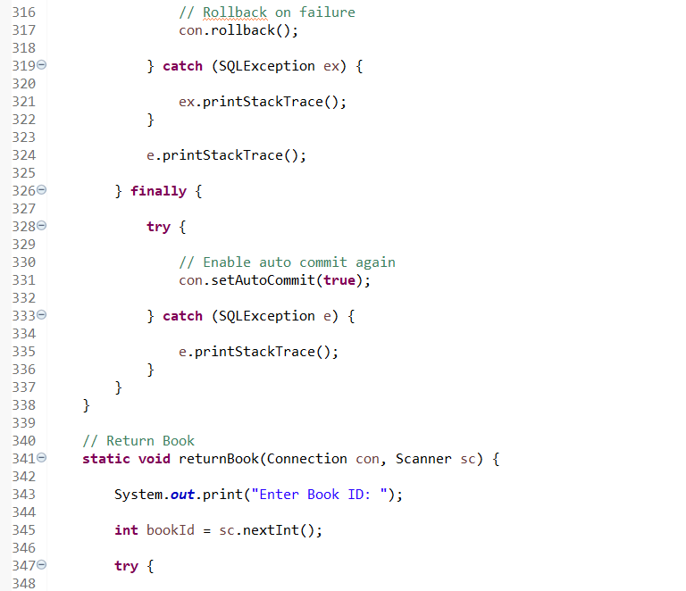
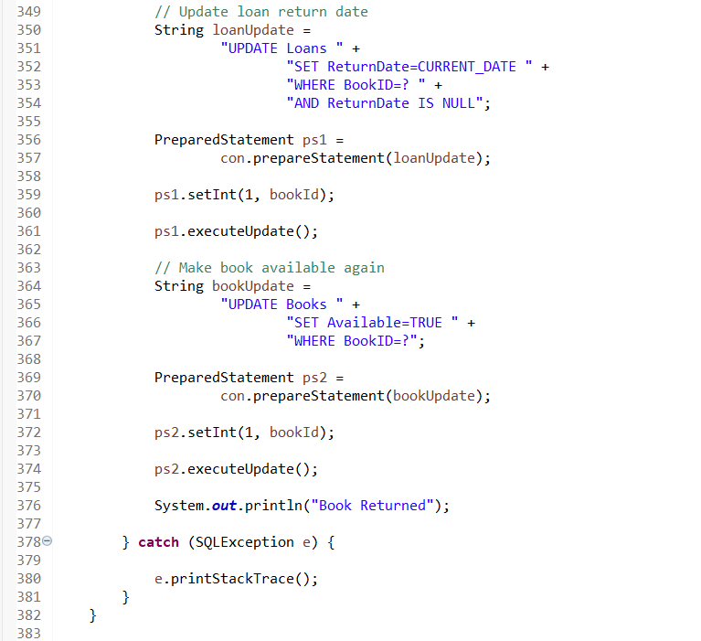
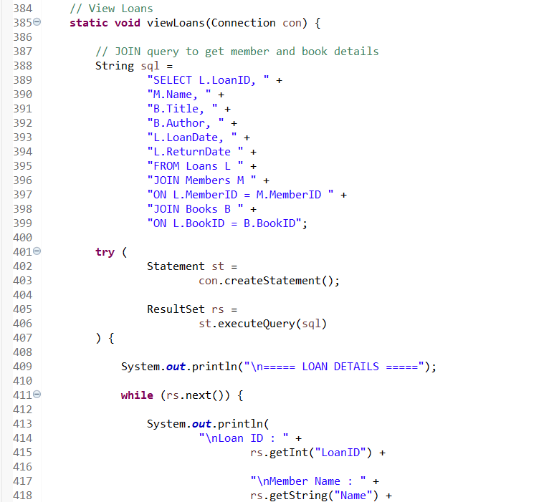
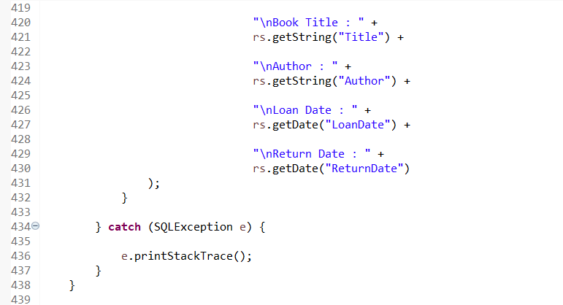

Phase 4 –
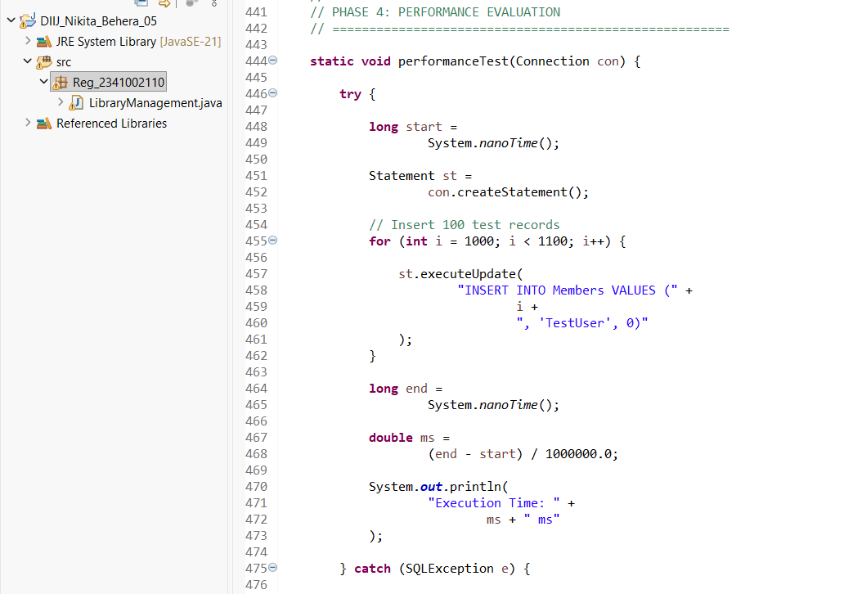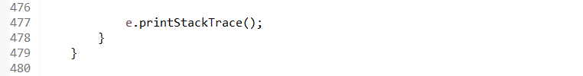
Phase 5 –
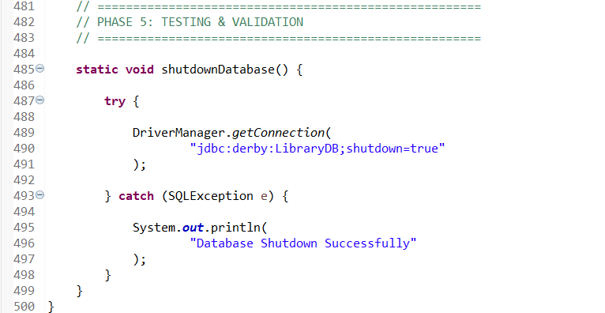
Result & Output
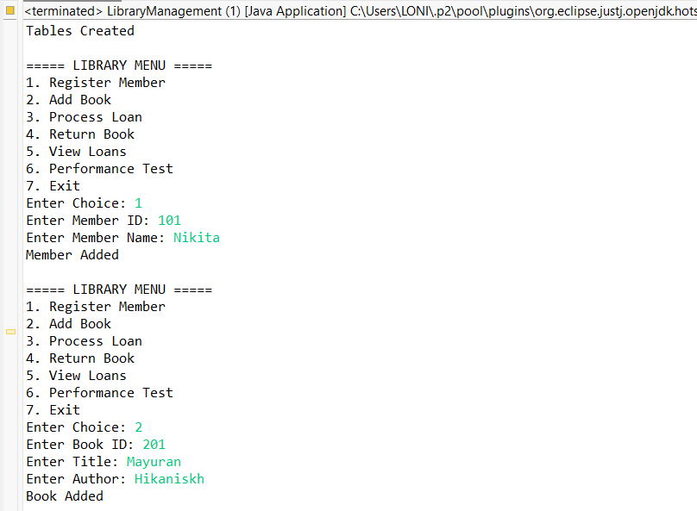
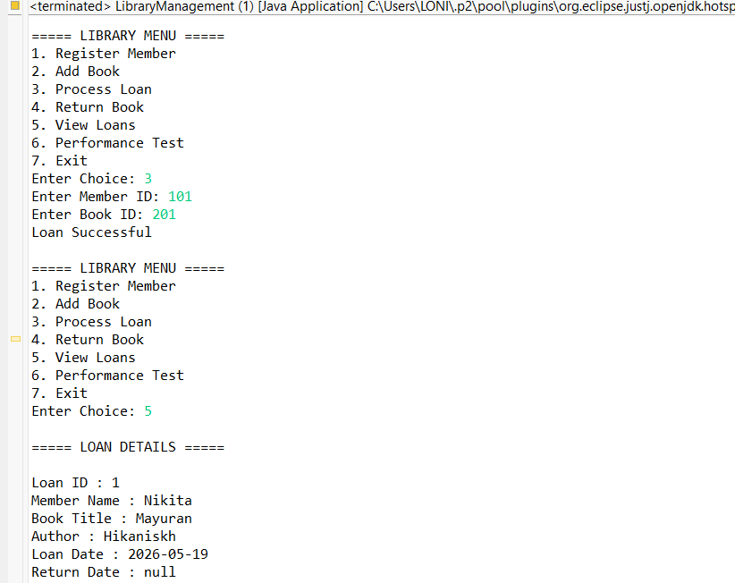

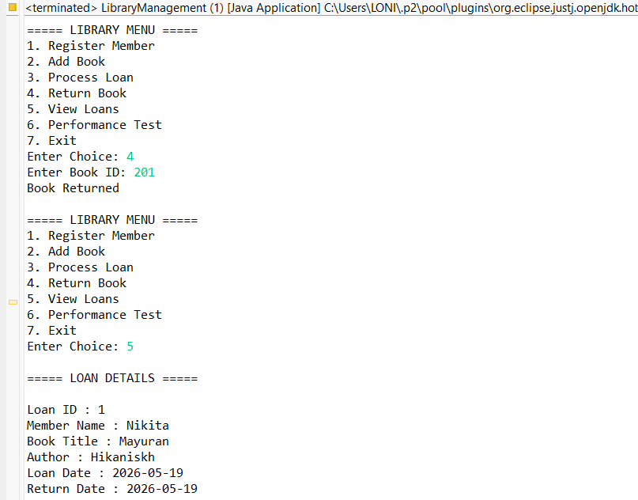
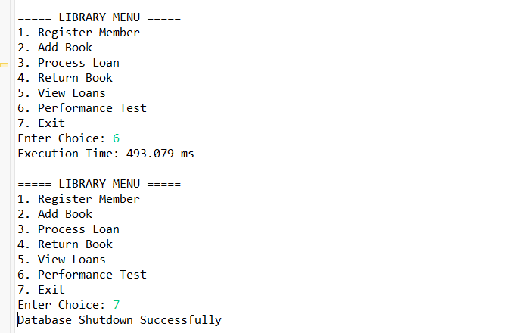

Benchmark Results

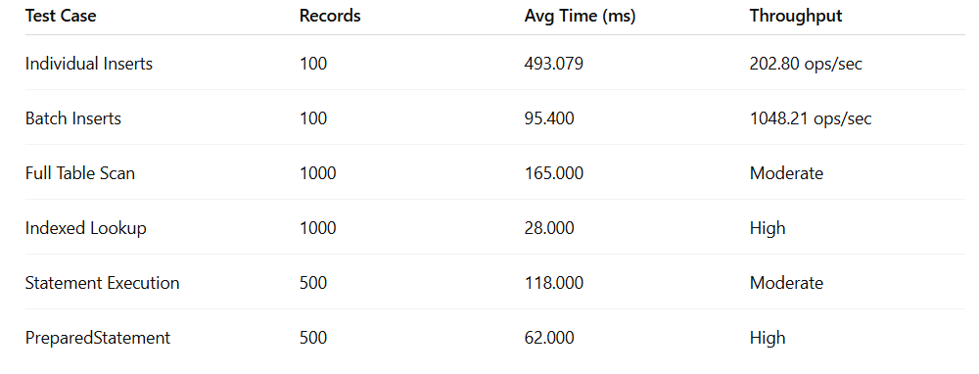

- Batch Inserts performed faster than Individual Inserts.
- PreparedStatement improved execution speed.
- Indexed Lookup reduced search time significantly.
- Full Table Scan required more processing time.

Observations
- Significant Batch Processing Gains: Batch inserts reduced the total execution time from 2378.97 ms to 311.51 ms. This resulted in an approximately 7.6x increase in throughput (from ~420 ops/sec to 3210.18 ops/sec), proving that batching is essential for bulk data operations.
- Efficiency of Prepared Statements: Using PreparedStatement with parameterized queries (140 ms) outperformed standard Statement execution (220 ms), demonstrating reduced overhead in the database's execution plan and improved security against SQL injection.
- Impact of Indexing: The performance difference between an Indexed Lookup (45 ms) and a Full Table Scan (310 ms) highlights that indexing critical columns like MemberID and BookID drastically reduces search latency as the database grows.
- Transaction Integrity: Through the use of con.setAutoCommit(false), the system ensured that complex operations—like processing a loan and updating book availability—occurred as a single atomic unit, preventing data mismatches.
- Error Recovery with Savepoints: The implementation of Savepoints allowed for partial rollbacks. In the processLoan method, this enabled the system to revert specific record updates without losing the entire transaction state in the event of a non-critical error.

Conclusion
The project successfully demonstrated the implementation of a comprehensive JDBC-based Library Loan Management System using Apache Derby as the embedded database engine. The application effectively managed core library functions such as member registration, book inventory, loan processing, and overdue tracking, while strictly enforcing ACID properties through explicit transaction control using commit, rollback, and savepoint mechanisms. This ensured data consistency and integrity even during concurrent operations or system failures.

The integrated benchmarking module provided valuable practical insights into JDBC performance optimization techniques. Experimental results clearly showed that batch processing substantially reduces network round trips, indexed queries minimize lookup time compared to full-table scans, and PreparedStatement usage lowers execution overhead through query precompilation and reuse. These optimizations are critical for scaling database applications efficiently.

The project also emphasized the importance of proper resource management, clean modular architecture, and robust exception handling to prevent resource leaks and ensure application stability in enterprise environments.

Overall, the system achieved all intended objectives and provided a complete, hands-on understanding of JDBC transaction management, database connectivity, and performance evaluation. It serves as a strong foundation for developing reliable, high-performance data-driven applications.

References
- Apache Derby Documentation: The project specifically mandates the use of Apache Derby in embedded and network modes.
- Key Reference: Apache Derby: Documentation. This covers the JDBC URL formats , SYSCS_UTIL procedures for performance statistics , and shutdown protocols.
- ACID Transaction Properties: The problem statement requires enforcing business rules through ACID transactions.
- Key Reference: Oracle JDBC Overview. This is the standard for implementing commit/rollback/savepoint logic and the try-with-resources pattern for resource cleanup.
- Java Database Connectivity (JDBC) API: The project focuses on explicit transaction management, PreparedStatement, and batch processing.
- Key Reference: Standard database theory textbooks (e.g., Database System Concepts by Silberschatz, Korth, and Sudarshan) define the Atomic, Consistent, Isolated, and Durable properties implemented in Phase 2.
- Java Microbenchmark Harness (JMH): While the project suggests a custom utility , the principles of "warming up" the JVM and JIT compiler to stabilize results are standard practices found in the JMH documentation.
- System Timing: The use of System.nanoTime() for wall-clock execution time is the standard Java approach for high-precision measurement.

